**INSTITUT SUPÉRIEUR D’ÉLECTRONIQUE DE PARIS - ISEP**

ÉCOLE D’INGÉNIEURS DU NUMERIQUE



*REPORT*

**Satellite team in Ka band**

**Group 5 members:**

**Zheng Shuqi**

**He Jing**

**Wang Miaojie**

**Anthony AGNEL**

**Wang Jing**

***11/01/2018***

**Table of contents**

**1.Ka band introduction** **2**

**2. Satellite specification** **3**

(1)Performances and parameters of existing satellites 3

a.HYLAS-1 (Launched 26 November 2010) 3

b. KA-SAT (Lanched 26 December 2010) 3

c.ViaSat-1 (Launched October 19, 2011 aboard a Proton rocket) 4

(2) Specification of our team’s satellite -- ISEP-G5 4

**3. Gateway configuration** **5**

(1)Gateway/UT Beam Parameters 6

a.Mixed Ka and Q/V solution 6

b.UT Beam 6

(2) Smart Gateway 7

**4. Financial cost** **7**

**5. Business plan** **8**

**6. R&D projects** **8**

**7. Tasks and distribution of the work** **9**

(1)duration of work and future work management 9

(2)distribution of the work 9

**8. References** **9**

# 

# 

# 1.Ka band introduction

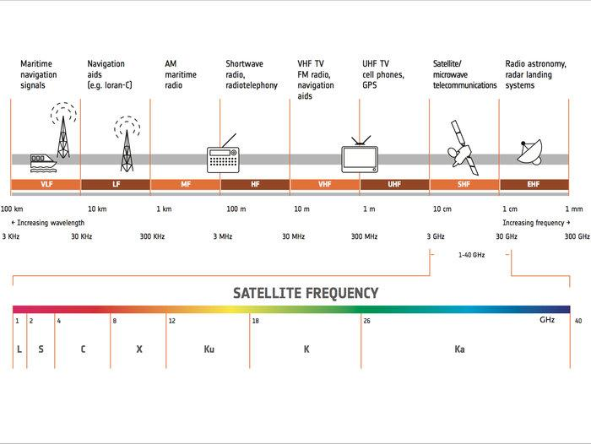

Ka band occupies approximately 26.5~40 GHz of the electromagnetic spectrum, it has higher speed, operates with smaller satellite dish and cheaper.

Beams generated in Ka band are much more directive than lower frequency bands. Moreover, we have more frequency in Ka band (26.5-40 GHz) than in Ku band (12-18 GHz). This is why Ka band increases the capacity offered and permit to propose lower prices.

The main issue of Ka band is the higher susceptibility to rain fade (than with Ku) which can be an issue in regions with high rates of precipitations. However, standards such as DVB-S2 allow to modify the waveform depending on the propagation conditions.

Eventually, a big advantage for Ka band is about Antennas. In fact, for the same diameter, with Ka band we will have a better transmit gain. Or on the same way, for a gain needed, we will have a smaller antenna with Ka band which will reduce space and weight needed for transportation.

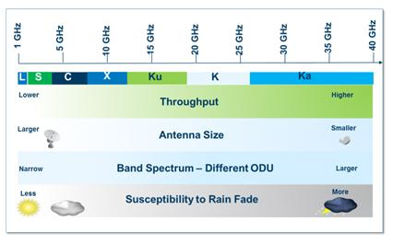

# 2. Satellite specification

## (1)Performances and parameters of existing satellites

### a.HYLAS-1 (Launched 26 November 2010)

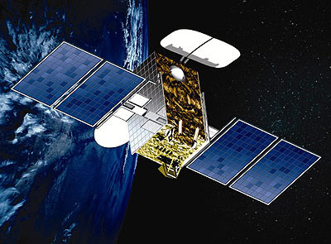

HYLAS-1 is the first Ka-band satellite launched by Avanti, it developed in Europe to provide high speed, two-way data services and low-cost internet access. It has very high power (>62 dBW) Spot Beams, orbital location 33.5 degrees West. The uplink data rates are between 768 kbit/s to 10 Mbit/s and the downlink data rates are between 512 kbit/s to 4 Mbit/s. It can support up to 300,000 two-way broadband customers across Europe. The EIRP for HYLAS-1 is up to 62 dBW at beam centre, G/T is about 14 dB/K.

### b. KA-SAT (Lanched 26 December 2010)

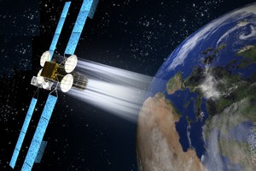

KA-SAT was developed by Europe, it provide high capacity satellite.The total throughput of KA-SAT beyond 90 Gbps. Gateways coverage all over Europe, orbital position 9° East. KA-SAT system includes seven different standard packages, has a maximum upload speed

6 Mbps and maximum download speed 20 Mbps.The EIRP for KA-SAT is up to 54 dBW at 39.75, G/T is about 23 dB/K. Transmit frequency range is from 28.1 to 30 GHz, receive range is from 18.3 to 20.2 GHz

### c.ViaSat-1 (Launched October 19, 2011 aboard a Proton rocket)

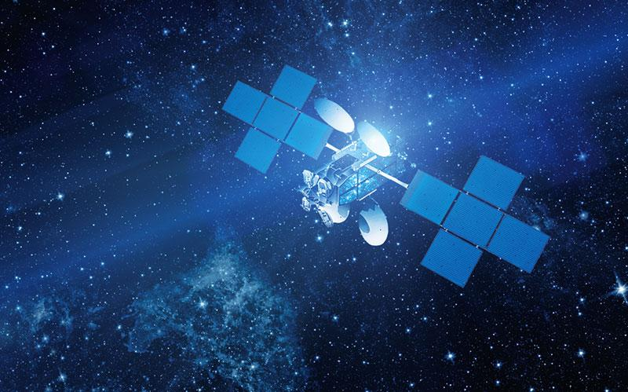

ViaSat-1 is a high throughput communications satellite owned by ViaSat Inc. and Telesat Canada. It held the Guinness record for the world's highest capacity communications satellite with a total capacity in excess of 140 Gbit/s, more than all the satellites covering North America combined, at the time of its launch. ViaSat-1 is capable of two-way communications with small dish antennas at higher speeds and a lower cost-per-bit than any satellite before. The satellite is positioned at 115.1 degrees West longitude geostationary orbit point, with 72 Ka-band spot beams; 63 over the U.S. (Eastern and Western states, Alaska and Hawaii), and nine over Canada. The EIRP for ViaSat-1 is up to 65.2 dBW, G/T is about 24.2 dB/K. Uplink frequency is 28.6 GHz and downlink frequency is 18.8 GHz.

## (2) Specification of our team’s satellite -- *ISEP-G5*

Main parameters:

Px=15dBw，

f=30GHz, (Ka band occupies approximately 26.5~40 GHz of the electromagnetic spectrum)

=0.6, (the aperture efficiency is typically 60%)

D=0.8 m, (the size of Ka band satellite is ususlly smaller than Ku band)

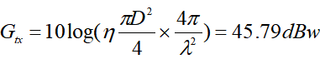

EIRP=Px+Gtx=15+45.79=60.79dBw,

T can only be analyzed under the assumption of a clear sky, so it has the similarities, we assume it to be 25 K, so G/T= Gtx-10lg(T)=31.81 dBw

Parameters which are difficult to ensure:

C/N is defined as ratio of carrier to total noise power which includes all internal system noise and interference from other system.

C/I is a widely accepted method for assessment of interference especially between geostationary satellite networks and is used for administrations for coordination of satellite network.

Forward channel Modulation/Coding

|  |  |
| --- | --- |
| QPSK | 1/3, 2/5, 1/2, 3/5, 2/3, 3/4, 4/5, 5/6 |
| 8PSK | 3/5, 2/3, 3/4, 5/6 |
| 16APSK | 2/3, 3/4, 4/5, 5/6, 8/9 |

Return channel Modulation/Coding

|  |  |
| --- | --- |
| BPSK | 1/2 |
| QPSK | 3/8, 1/2, 5/8, 3/4 |
| 8PSK | 7/12, 2/3, 3/4 |

Receive Frequency Range 18.3 to 30.2 GHz

Transmit Frequency Range 30.2 to 32.3 GHz

# 3. Gateway configuration

|  |  |
| --- | --- |
| Linearizers | YES |
| IBO | 6dB |
| OBO | 3dB |

When multiple carriers work in the same transponder, in order to avoid the intermodulation interference due to nonlinearities, it is necessary to control the transponder not to output too large to enter the nonlinear region. The transponder must return a certain number to make the amplifier work in a linear state, but at this point the output power of the entire repeater will be much lower than the maximum power. In order to reduce this loss, some transponders are equipped with a linearizer to improve the non-linearity of the amplifier.

The transponder with the linearizer, IBO is generally 6dB and OBO is 3 dB; If the linearization device is not taken, IBO is normally 9 dB and OBO is 4.5 dB. If a carrier occupies the entire transponder both IBO and OBO are 0dB.

## (1)Gateway/UT Beam Parameters

### a.Mixed Ka and Q/V solution

We have found that an initial architecture that employs the use of Q/V bands on the feeder links and Ka band for the UT appears to offer the best throughput. It should be noted that at Ka-band under existing regulation only 500 MHz would be in the exclusive satellite band and thus some of the UT’s would need to coordinate. This is not seen as a major hurdle but regulators would need to adopt an online fast-track scheme.

### b.UT Beam

The bandwidth available is 2.5 GHz on the uplink (all bandwidth allocated to the user link as the feeder link is at Q/V band) and potentially 3 GHz on the down. For 2.5 GHz, three frequency reuse colours and 32 APSK the initial numbers of beams is found to be around 175 (or 88 with dual polarization).

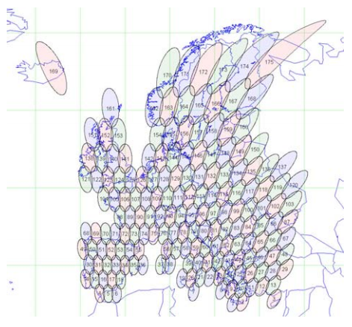

(175 single polarised user beams over Europe)

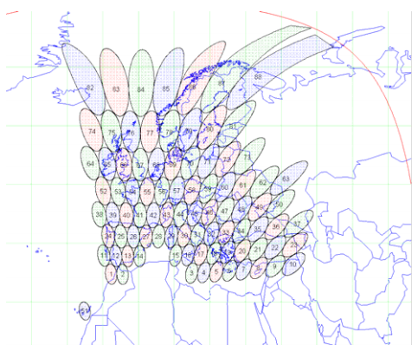

(88 dual polarised user beams over Europe)

## (2) Smart Gateway

The Smart Gateway architecture employs a number of Gateway Earth Stations which are inter-connected with terrestrial deeds to form an agile routing of feeder link data that can be used in a diversity manner to combat fades on the gateway to satellite links .

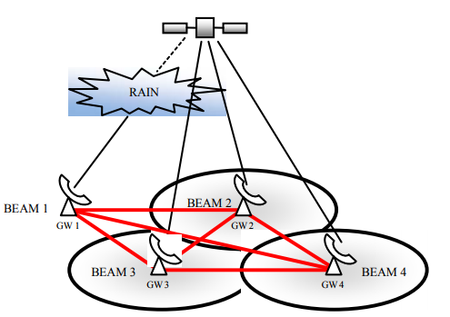

**According to this concept:**

− Existing gateways are inter-connected to form a terrestrial network.

− Each user is serviced by a number of gateway feeder links.

− In the event of a gateway experiencing outage or reduced capacity, some or all user traffic can be redirected terrestrially to any one of the remaining gateways, in any spot beam.

**Advantages:**

− Reduced cost → no additional gateways/antennas.

− Diversity gain → many more gateways, greater inter-site distance.

− Efficient gateway usage → all gateways simultaneously operational.

− Efficient resource usage → can utilise capacity wherever it exists.

− Implicit fault tolerance, opportunity to load balance and improve throughput.

**Disadvantages:**

− The allocation of gateway feeder link capacity to users is a critical function.

− Control/Switching algorithms required to detect capacity fluctuations and make traffic allocation decisions to achieve aims.

− A high degree of synchronisation in the gateway network is required.

− Some level of ‘intelligence’ is required in the Network and terminals.

# 4. Financial cost

We plan to launch the first ISEP-G5 satellite in 2020 to provide the local broadcast, which cost about 350 million euros.

|  |  |
| --- | --- |
| **Items** | **Costs(million euros)** |
| Satellite manufacturing | 350 |
| Satellite launching | 150 |
| Satellite Insurance | 70 |
| Maintenance | 10/year |

# 5. Business plan

The first ISEP-G5 satellite will be launched in 2020 to provide local broadcast. ISEP-G5’s coverage area is smaller than other satellites but has a coveraged population of 800 million people in France.

We plan to 1)cooperate with telecom operators, users pay 30€~90€ each month can get permissions to use Internet or HDTV, we will provide low competitive price of equipment and high speed rate for IP streaming contribution up to HD contents.

2)we can also provide Internet access for airplane, high-speed rail and vessel.

After that, we plan to launch other ISEP-G5 satellites to provide global broadcast.

# 6. R&D projects

In the future, we will pay our attention to high-frequency-band and low-orbit satellite and apply our services in the field of cloud computing, cloud platform, big data, as well as the newly emerging blockchain technology that is not yet familiar to the general public.

Explore new solution on how to minimize the influence of rain.

Multibeam satellite communication system technology

# 7. Tasks and distribution of the work

## (1)duration of work and future work management

20/10~25/10: Search information about Ka-band satellite.

26/10~31/10: Pre-design and make specifications of our satellite,

Decide parameters and consider the configuration of gateway.

01/11~07/11: Consider about the financial cost and make a initial business plan.

08/11~09/12: System feasibility analysis,

Modify and consummate the previous financial cost and business plan.

10/12~11/01/2018: Modify and consummate the whole system.

## (2)distribution of the work

|  |  |  |  |  |  |
| --- | --- | --- | --- | --- | --- |
|  | information gathering | satellite specification | gateway consideration | Feasibility analysis | Financial cost and business plan |
| Anthony Agnel | √ |  |  | √ | √ |
| Zheng Shuqi | √ | √ |  | √ |  |
| Wang Jing |  | √ | √ | √ |  |
| He Jing |  | √ |  | √ | √ |
| Wang Miaojie | √ | √ | √ | √ |  |

# 8. References

<https://directory.eoportal.org/web/eoportal/satellite-missions/h/hylas>

<http://www.eutelsat.com/files/contributed/news/media_library/brochures/ka-sat-professional-services.pdf>

*Concepts and Technologies for a Terabit/s Satellite*

https://www.fool.com/investing/2016/06/24/how-much-does-it-cost-to-launch-a-satellite.aspx

*How Much Does It Cost to Launch a Satellite?*

http://spacenews.com/ka-sat-enters-service-european-broadband-market-heats